GROUP BY & HAVING
OUTPUT:


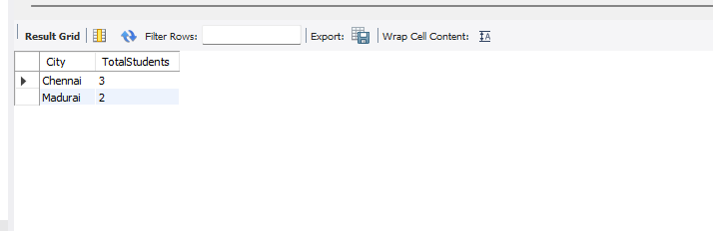
Explanation
GROUP BY City groups students based on their city, and COUNT(*) counts the number of students in each city.
HAVING COUNT(*) > 1 displays only the cities that have more than one student.

